

**ELTR 2192**

**SPECIAL PROJECTS**

**3D PRINTING**

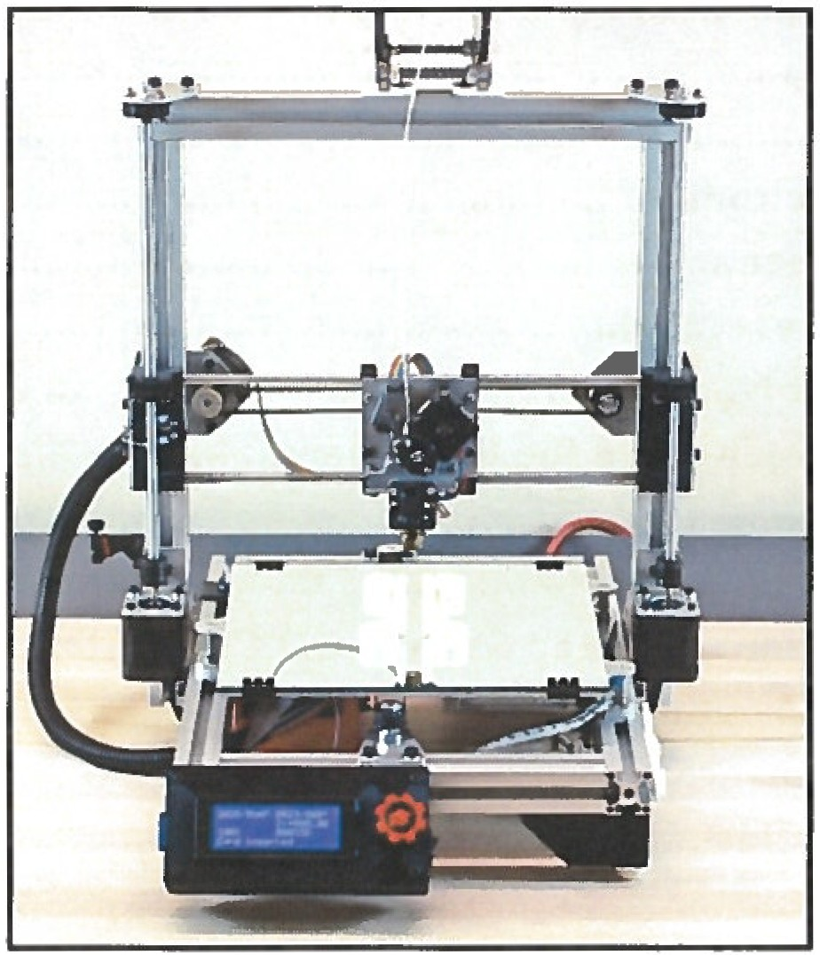

Featuring the "flexMendel”